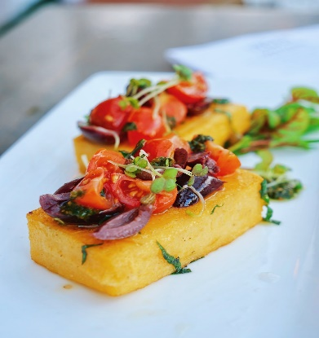


HORS D’OEUVRES
All Hors D’oeuvres are priced per person

Vegetable Spring Rolls ………………………………………………………………………………………3.75…
Seafood eggrolls………………………………………………………………………………………………8.99…
Jerk chicken eggrolls…………………………………………………………………………………………6.75
Southwest eggrolls………………………………………………………………………………………………6.75.
Burger buys eggrolls………………………………………………………………………………………………6.75
Shrimp with tangy cocktail dipping sauce…………………………………………………………….6.99.
Grilled scallops ………………………………………………………………………………………………………mkt..
Mini-beef Meatballs …………………………………………………………………………………165(pan)
Crab dip(Parties under 50)…………………………………………………………………………………mkt…
Buffalo chicken dip………………………………………………………………………………………………9.99
Spinach artichoke dip……………………………………………………………………………………………9.89.
Hamburger Sliders with cheese…………………………………………………………………………………9.99
Homerun Pulled Pork Sliders……………………………………………………………………………MKT
Salmon Cakes Balls with a chipotle Ahoy…………………………………………………………………6.75
Shrimp Salmon Cakes……………………………………………………………………………………….. 7.50
Maryland Crab Balls…………………………………………………………………………………………….. MKT
Garlic-Cilantro Shrimp…………………………………………………………………………………………. MKT
Fried Chicken Wings-original and/or choice of flavor………………………………………………MKT
Mediterranean Chicken Skewers…………………………………………………………………………… 8.99
Beef Patties………………………………………………………………………………………………………..6.99
Tomato bruschetta on toasted crostini drizzled with balsamic glaze …………………….4.00
Boneless Wings (Assorted Flavors) ………………………………………………………………8.99
Korean Crispy Calamari……………………………………………………………………………………MKT
Curry Chicken Sliders…………………………………………………………………………………………9.99
Sweet Plantains……………………………………………………………………………………………..6.99
Spinach Spanakopita …………………………………………………………………………………….7.99
Charcuterie Graze……………………………………………………………………………………… 15 per person

ENTREES
All Entrees are priced Per Person

Plated Style Options
Below you will find some popular choices.
Grilled Salmon served over Asparagus and Garlic Mashed Potatoes $55
Herb Roasted Cornish Hen with Green beans and Mashed Potatoes $40
Grilled chicken breast Mushroom cream sauce served w/ wild rice and sauteed spinach $45.99
Surf and Turf with baked potatoes and veggies MKT$$$
New York Strip Steak with Asparagus and Garlic Mashed Potatoes $65.99
Half Roasted Chicken served with a chickpea stew $40
Red Snapper with wild rice and veggies $55
Beef Tenderloin and Grilled Shrimp with Risotto and carrots MKT
Chicken Chesapeake with spinach and Mashed potatoes $60

Buffet Style

Chicken

Herb Roasted Chicken(Plain, BBQ, Lemon pepper) …… 14.99
Grilled Boneless Tuscan Chicken ……. 17.85
Chopped Grilled Chicken Breasts made with roasted orange peppers, bell peppers, and onions ………. 16.99
Smothered chicken ……14.99
Southern fried chicken ……. 15.85
Chicken and dumplings ….14.99

Seafood
Creamy Salmon and Grits …..27.85
Shrimp and grits ……24.99
Salmon Cakes ….15.95
Crab Cakes …..MKT
Lemon Pepper Tilapia Fillets …….16.99
Tuscan salmon 19.85
Jerk Shrimp Skewers with a lime garnish 20.95
Salmon Wellington 34.95
Stuffed seafood Wellington MKT
Lobster Tails MKT

Turkey
Smoked Turkey Wings 18.99
Oven Roasted Turkey MKT

Beef
New York strip steak 32.99
Sliced Beef Tenderloin 39.89
Skirt steak 35.00
Grilled Ribeye 54.59
Savory Pot Roast 15.99
Pepper Steak 16.99
Surf And Turf Mkt
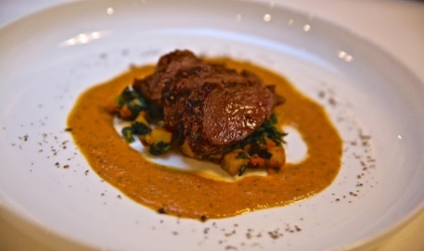
Grilled Filet Mignon with savory steak sauce ($$$)
Prime Rib ($$$$)

Pork
Pulled Pork in a sweet and tangy barbeque sauce
Pork Ribs
Smothered pork chops
Brazed Short Ribs with mashed potatoes

Lamb (Premium)
Lamb Chops

Pasta
Grilled Chicken with Alfredo sauce and penne pasta ….18.99
Rasta pasta…… 18.99
Cajun Chicken and Shrimp 17.88
Tuscan pasta 19.99
Chicken pesto pasta 10.99
Baked Ziti made with ground beef or ground turkey 210
Baked Lasagna made with ground beef or ground turkey 210

Vegetarian/ Vegan

Vegan Coconut Curry Chickpeas served with Basmati Rice 9.99
Thai Basil Vegetable dumplings with tofu, peppers, and onions, 15.99

Caribbean
Curry goat MKT
Ackee and Saltfish 16.99
Oxtail MKT
Stew pork 19.99
Curry coconut shrimp 19.99
Curry chicken and potatoes 16.99
Jerk chicken 16.99
Jerk Pork 19.99
Brown Stew Chicken 16.99
Red Snapper …… 28.89
Fried King Fish (additional cost for escovitch dressing) …. 45.95

Stations
Build your own taco bar
Waffle station
Build your own Sundaes station
Mash Potato Bat with Topping, Chopped chicken, bacon bits, cheese chives, sour cream
Mash Potato Bar
Turkey Carving Station
Candy Station

SIDE DISHES
All sides come by the tray. Each tray feed 15-20 people on average

Sweet potatoes in a brown sugar cinnamon glaze…………………………. 130
Honey cornbread………………………………………………………………………. 80
Fried Sweet Plantains………………………………………………………….... 105
Rice (Yellow, Jasmine, Cajun, Seafood, Fried, Rice and Peas)………………………. 120
Southern Baked Macaroni and Cheese…………………………………………………………….150
Seafood macaroni and cheese…………………………………………………………………………. 220
Lobster macaroni and cheese………………………………………………………………… MKT
Potato Salad ……… 130
Seafood salad ……………………………………………………150
Pesto pasta…………………………………………………………………………………………………………120
Shrimp Pasta Salad …………………………………………… 120
VEGETABLES

Steamed Cabbage and Carrots with light seasoning………………………………….120
Collard Greens without Turkey………………………………………………………………………………. 135
Collard Greens with Turkey…………………………………………………………………………………… 175
Steamed Broccoli…………………………………………………………………………………….120
Garlic herb sautéed green beans…………………………………………………. 120
Garlic herb roasted potatoes…………………………………………………. 135
Parmesan garlic mashed potatoes………………………………………………140
Garlic Mashed Potatoes………………………………………………………………………130
Seasonal Vegetables made with olive oil and fresh herbs………………………………95
Pan Sautéed Baby Spinach with Shallots and roasted garlic…………………………….120
Grilled Asparagus in a lemon butter sauce ………………………………………………120
Loaded baked potatoes with bacon and cheese…………………………………………. 135
Cauliflower Rice……………………………………………………………………………………….90

SALADS
House Salad with romaine lettuce, red onions, tomatoes, carrots, cheese, and cucumbers with choice of dressing
Caesar Salad with romaine lettuce, croutons, Parmesan cheese, and Cesar dressing
Arugula and spinach lettuce, grape tomatoes, red onions, cucumbers, and Raspberry or Balsamic dressing
Strawberry Walnut Salad with strawberries, walnuts, spring mix, red onions, parmesan cheese, and raspberry balsamic dressing

SOUPS
Tomato Basil Soup
Potato Soup with cheese and bacon
Cream of crab soup
Broccoli cheddar soup
Chicken noodle soup
Cabbage Soup
Chicken foot soup
Coconut curried cauliflower soup
Creamy chicken tortilla soup
Lobster Bisque

DESSERTS
Cheesecake Bar
Banana Pudding
Strawberry lemon bar
Pumpkin Pie (Seasonal)
Pecan Pie (Seasonal)
Cake (Carrot, red velvet, chocolate)

MOCKTAILS
Pineapple Ginger Tune-up
(Pineapple, Ginger, Lemon)

Papaya-u lying
(Sweet papaya, guava, peach nectar, and ginger)

Jamaican me crazy
Strawberry, pineapple, ginger, orange juice

Passion gives you wings
Passion fruit juice, guava nectar

